Example
Business plan 2027–2029
Studio Lumen
36-month financial forecast, January 2027 to December 2029.
Prepared for Jamie Carter

Issued 17 October 2026
Amounts in GBP, excluding tax. Figures built from the founder's own assumptions.

Summary
Five key figures. Each one is detailed in the following chapters.
Revenue, year 3  £450k | Sales grow from £270k in year 1 to £450k in year 3, up 66%.  Year 2: £379k.
Net profit, year 3  £80k | After a first year at −£9.9k, the business turns profitable in year 2.  Cumulative net profit over 3 years: £117k.
Break-even  Month 9 | Monthly revenue passes the break-even point in September 2027.  Break-even in year 3: £24k of sales per month. EBITDA is positive from month 7.
Lowest cash balance  £39k | Cash never falls below zero; its lowest point comes in September 2027.  It ends the period at £152k.
Funding resources  £110k | Equity and loan cover 1.8 times the need of £62k.  Safety margin: £48k.

In short
With these assumptions, the business breaks even within the first year, stays funded throughout and generates £80k of net profit in year 3. Sensitivity to the average price is detailed on page 7.

Assumptions
Every figure in this plan follows from the 23 assumptions below.

Project
Project name | Studio Lumen
Display currency | GBP
Start date  First month of the model. | January 2027

Sales
Average price per sale (excl. tax)  Average basket or average unit price. | £180 | per sale
Sales in the first month  Expected volume in the launch month. | 100 | sales
Monthly sales growth, year 1  Compound monthly rate. | 4.0% | per month
Monthly sales growth, year 2 | 2.0% | per month
Monthly sales growth, year 3 | 1.0% | per month

Costs
Variable costs (materials, subcontracting, commissions)  Proportional to revenue. | 30.0% | of revenue
Marketing and acquisition | 8.0% | of revenue
Monthly fixed costs (rent, software, insurance...)  Excluding salaries. | £5,000 | per month
Annual increase in fixed costs  Applied at the start of each new year. | 3.0% | per year
Team gross salaries, monthly  Total gross pay, all roles. | £7,000 | per month
Employer payroll taxes | 25.0% | of gross pay

Investment and funding
Start-up investment  Equipment, fit-out, website, deposits. | £40,000 | month 1
Depreciation period  Straight-line. | 5 | years
Owner's equity | £50,000 | month 1
Bank loan | £60,000 | month 1
Annual loan interest rate | 6.0% | per year
Loan term  Repaid in equal monthly instalments. | 60 | months
Tax rate on profit  Applied when profit before tax is positive (monthly simplification). | 20.0% | of profit

Payment terms
Customer payment terms | 30 | days
Supplier payment terms | 30 | days

Three-year profit and loss
From revenue to net profit, year by year. Variable costs and marketing move with sales; fixed costs and salaries do not.
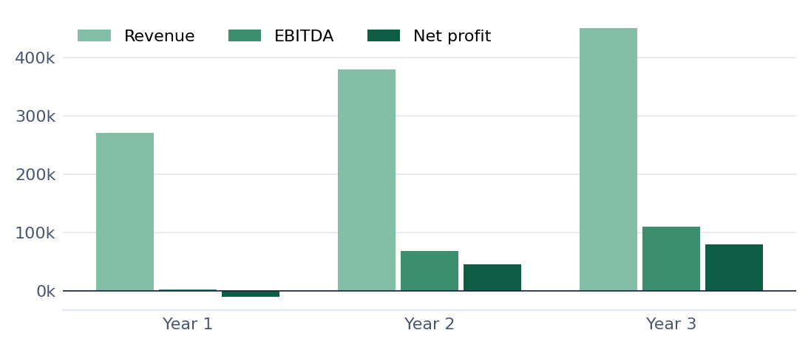
In GBP | Year 1 | Year 2 | Year 3
Revenue | 270,464 | 379,084 | 450,161
Variable costs | (81,139) | (113,725) | (135,048)
Marketing | (21,637) | (30,327) | (36,013)
Contribution margin | 167,688 | 235,032 | 279,100
Fixed costs | (60,000) | (61,800) | (63,654)
Salaries incl. payroll taxes | (105,000) | (105,000) | (105,000)
EBITDA | 2,688 | 68,232 | 110,446
Depreciation | (8,000) | (8,000) | (8,000)
Operating profit | (5,312) | 60,232 | 102,446
Loan interest | (3,311) | (2,657) | (1,962)
Profit before tax | (8,623) | 57,575 | 100,483
Tax on profit | (1,232) | (11,515) | (20,097)
Net profit | (9,855) | 46,060 | 80,387

Ratios | Year 1 | Year 2 | Year 3
Revenue growth | n/a | 40.0% | 19.0%
Contribution margin rate | 62.0% | 62.0% | 62.0%
EBITDA margin | 1.0% | 18.0% | 25.0%
Net margin | −4.0% | 12.0% | 18.0%

Cash over 36 months
The bank balance at the end of each month, including equity and loan. The dotted line shows it with no funding at all: its lowest point measures the need.
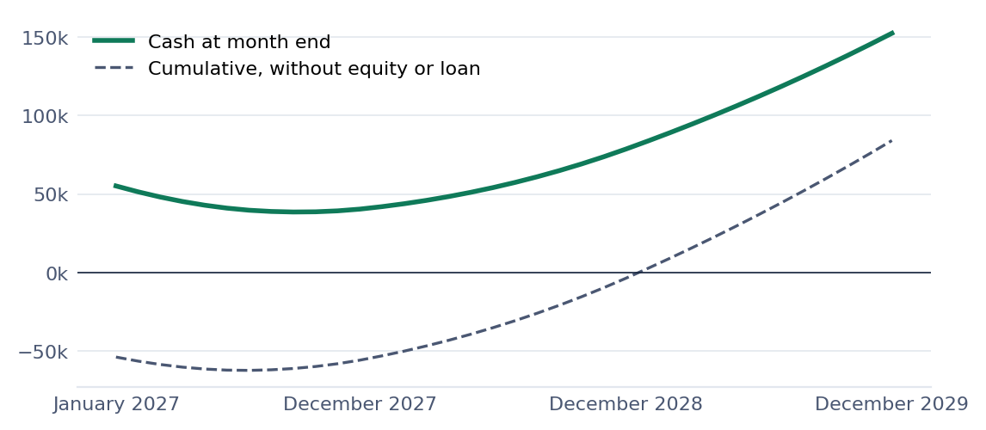

By quarter (in thousands)
 | Q1 27 | Q2 27 | Q3 27 | Q4 27 | Q1 28 | Q2 28
Operations | (18.5) | (3.6) | 1.0 | 5.3 | 9.0 | 11.6
Investment | (40.0) | – | – | – | – | –
Financing | 106.5 | (3.5) | (3.5) | (3.5) | (3.5) | (3.5)
Closing cash | 48.0 | 41.0 | 38.5 | 40.4 | 45.9 | 54.0

 | Q3 28 | Q4 28 | Q1 29 | Q2 29 | Q3 29 | Q4 29
Operations | 14.3 | 17.2 | 19.5 | 21.1 | 22.7 | 24.4
Investment | – | – | – | – | – | –
Financing | (3.5) | (3.5) | (3.5) | (3.5) | (3.5) | (3.5)
Closing cash | 64.8 | 78.5 | 94.5 | 112.1 | 131.3 | 152.2

By year
In GBP | Year 1 | Year 2 | Year 3
Operating cash flow | (15,724) | 52,109 | 87,586
Start-up investment | (40,000) | – | –
Financing cash flow | 96,080 | (13,920) | (13,920)
Change in cash | 40,357 | 38,189 | 73,666
Cash at year end | 40,357 | 78,546 | 152,212

Funding and break-even
What must be funded at the start, with what, and from when the business covers all its costs on its own.

Needs and resources (surplus of £48k)
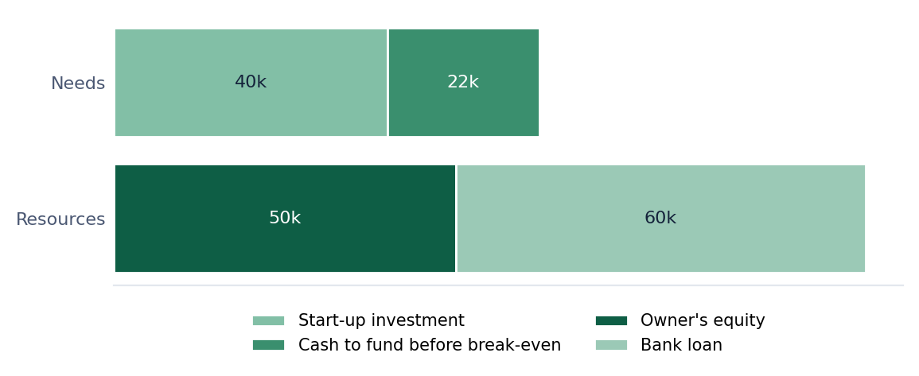
Loan of £60k over 60 months at 6.0% | Year 1 | Year 2 | Year 3
Interest paid | 3,311 | 2,657 | 1,962
Principal repaid | 10,608 | 11,262 | 11,957
Outstanding principal at year end | 49,392 | 38,129 | 26,172

Fixed monthly instalment: £1,160.

When sales cover all costs
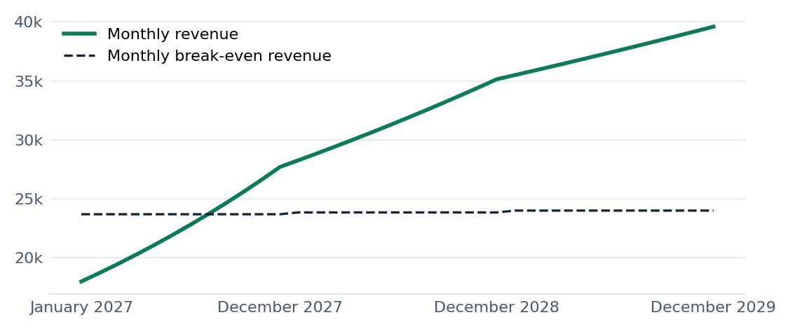
Break-even | Year 1 | Year 2 | Year 3
Fixed costs to cover | 176,311 | 177,457 | 178,616
Annual break-even revenue | 284,373 | 286,221 | 288,091
Margin of safety | −5.0% | 24.0% | 36.0%

Sensitivity of the plan
Each line changes a single assumption and reruns the 1,540 formulas of the workbook. The grey bar shows the downside case, the green bar the upside.
Cumulative net profit over 3 years | Lowest cash balance
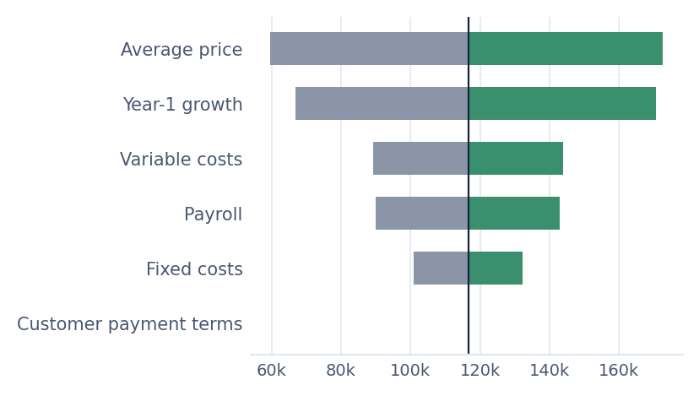 | 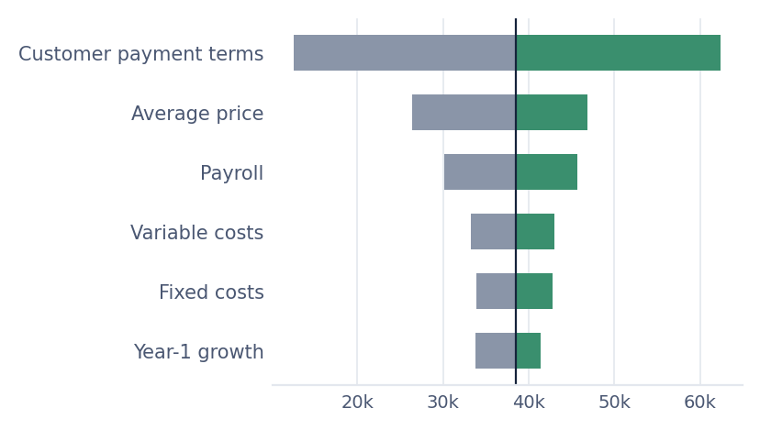

Largest downside changes
1. Average price −10%: cumulative net profit down £57k, lowest cash at £26k.
2. Year-1 growth −1 pt: cumulative net profit down £50k, lowest cash at £34k.
3. Variable costs +3 pts: cumulative net profit down £27k, lowest cash at £33k.
4. Customers paying 30 days later: no effect on profit, but cash falls to £13k.

Largest upside changes
1. Average price +10%: +£56k of cumulative net profit, lowest cash at £47k.
2. Year-1 growth +1 pt: +£54k of cumulative net profit, lowest cash at £41k.
3. Variable costs −3 pts: +£27k of cumulative net profit, lowest cash at £43k.
Each scenario changes a single assumption; all others stay the same. Base case: cumulative net profit £116,592, lowest cash balance £38,523.

Method
How the figures are calculated, and the limits of the model.

Model structure
The workbook calculates, for each of 36 months, sales, costs, profit, the loan and cash. Annual tables are the sum of the months. Only one sheet takes inputs, Assumptions; the 1,540 formulas do the rest.

Sales
First-month volume, then compound monthly growth, with one rate per year. Revenue is volume multiplied by the average price, excluding tax.

Costs
Variable costs and marketing as a percentage of revenue. Monthly fixed costs raised each year by the increase rate. Gross salaries plus employer payroll taxes. Investment depreciated on a straight-line basis.

Funding
Equity and loan received in the first month. Loan repaid in equal monthly instalments. The funding need is the investment plus the lowest cash point before any funding.

Cash
EBITDA, less tax, adjusted for customer and supplier payment terms, less investment, plus net funding.

Reading conventions
Amounts exclude tax. In the tables, negative amounts are shown in brackets and a dash marks a zero value.

Limits
VAT or sales tax, seasonality, inventory and staggered hiring are not modelled. Tax is a monthly approximation. Amounts are not converted between currencies.

Glossary
EBITDA: Earnings before interest, tax, depreciation and amortisation: what the business generates before depreciation, interest and tax.
Break-even: The level of sales at which all costs, fixed and variable, are covered.
Margin of safety: The share of revenue above break-even: how far sales can fall before a loss.
Outstanding principal: What remains to be repaid on the loan.
Document issued 17 October 2026. The forecast rests entirely on the founder's assumptions; it is not advice, an audit, or a guarantee of results or of funding.
Calculation model: ExcelBP (excelbp.com)

